### 

**FACULTY COMPUTER SYSTEM & SOFTWARE ENGINEERING**

### TEST DESIGN

### SPECIFICATIONS

FOOD ORDERING SYSTEM (FOS)

ORDER FOOD AND DRINK

Independent Verification and Validation

Version: 1.0.0

Date: 21/11/2016

**Document Control**

|  |  |
| --- | --- |
| **Document Name** | FOS Test Design Specification |
| **Reference Number** | FOS_TDS |
| **Version** | 1.0.0 |
| **Project Code** | TZARIA INC._FOS |
| **Status** | In-Use |
| **Date Released** | 21st of Nov, 2016 |

|  |  |  |  |
| --- | --- | --- | --- |
| **Name** | | **Position** | **Contact Number** |
| Prepared By*:*  NUR SHAHIRAH BINTI MOHAMAD FAIZAL | Test Manager  TZARIA INC. |  |
| Reviewed By:  NUR ZAHIRAH BINTI ROSLAN | | Quality Assurance Team  TZARIA INC. |  |

**Version History**

|  |  |  |  |
| --- | --- | --- | --- |
| **Version** | **Release Date** | **Section** | **Amendments** |
| 1.0.0 | 21/11/2016 | All | Original Document |

**Distribution List**

|  |  |  |  |  |  |  |
| --- | --- | --- | --- | --- | --- | --- |
| **Version** | **Release Date** | **Contolled Copy No** | **Receipient Name** | **Department** | **Issue Date** | **Return Date** |
| 1.0.0 | 21/11/2016 | 01 |  | TZARIA INC. QA Dept. | 21/11/2016 |  |
| 1.0.0 | 21/11/2016 | 02 |  | TZARIA INC. Test Team | 21/11/2016 |  |
| 1.0.0 | 21/11/2016 | 03 |  | NKMM | 21/11/2016 |  |

**Table of Content**

Document Control i

Version History ii

Distribution List ii

Table of Content iii

1.0 Introduction 1

1.1 Purpose 1

1.2 Scope 1

1.3 References 1

2.0 Test Design 2

2.1 Features To Be Tested 2

2.2 Approach Refinements 2

2.3 Test Identification 8

2.4 Feature Pass/Fail Criteria 8

2.5 Test Deliverable 9

# 1.0 Introduction

|  |
| --- |
| 1.1 Purpose This test design specification support the following objectives:  i. To identify the test items covered  ii. To further refine the test approach from test plan  iii. To define the sources of the information used to prepare the plan  iv. To identify the general cases of test to be executed 1.2 Scope This test design specification covers Order Food and Drink features developed in FOS. |

## 1.3 References

The following IEEE standards have been referenced in preparation of this document:

i. IEEE 829-2008 Standard for Software and System Test Documentation

The following documents provide the test basis for this test design:

i. The FOS Software Requirement Specifications (FOS_SRS_2.0)

ii. The FOS System Design Document (FOS_SDD_2.0)

# 

# 2.0 Test Design

## 2.1 Features To Be Tested

The following table contains the features to be tested based on FOS Software Requirement Specification (SRS) for this iteration. Listed together are the function ID and its corresponding function and its risk level.

|  |  |  |
| --- | --- | --- |
| **Feature ID** | **Description** | **Risk Level** |
| F002 | Order Food and Drink | High |

**2.2 Approach Refinements**

Feature ID: F002

Test Technique: Decision table testing, Use case testing, State Transition Testing

Result Analysis Method:

**2.2.1 Decision Table Testing**

|  |  |
| --- | --- |
| Test Condition ID | Test Condition |
| TCON-02-001 | Click “Menu” button |
| TCON-02-002 | Click “Set Meals” button |
| TCON-02-003 | Click “Add Ons” button |
| TCON-02-004 | Click “AlaCarte” button |
| TCON-02-005 | Click “Drink” button |
| TCON-02-006 | Valid Order |
| TCON-02-007 | Click ”Order” button |
| TCON-02-008 | Tick list of food |
| TCON-02-009 | Click “Reset” button |
| TCON-02-010 | Tick”Dine In” or “Take Away” |
| TCON-02-011 | Click “Confirm” button |
| TCON-02-012 | Invalid Order |
| TCON-02-013 | Order again |

**Table 2.2.1a Session Verification Decision Table Test Conditions**

|  |  |  |  |  |  |  |  |  |  |  |  |
| --- | --- | --- | --- | --- | --- | --- | --- | --- | --- | --- | --- |
| Condition | T  C  O  V  -  02  -  001 | T  C  O  V  -  02  -  002 | T  C  O  V  -  02  -  003 | T  C  O  V  -  02  -  004 | T  C  O  V  -  02  -  005 | T  C  O  V  -  02  -  006 | T  C  O  V  -  02  -  007 | T  C  O  V  -  02  -  008 | T  C  O  V  -  02  -  009 | T  C  O  V  -  02  -  010 | T  C  O  V  -  02  -  011 |
| Click “Menu” button | Y | Y | Y | Y | Y | Y | Y | Y | Y | Y | Y |
| Click “Set Meals” button | N | Y | N | N | N | Y | Y | Y | Y | Y | Y |
| Click “Add Ons” button | N | N | Y | N | N | Y | Y | Y | Y | Y | Y |
| Click “AlaCarte” button | N | N | N | Y | N | Y | Y | Y | Y | Y | Y |
| Click “Drink” button | N | N | N | N | Y | Y | Y | Y | Y | Y | Y |
| Valid Order | N | Y | Y | Y | Y | N | Y | Y | Y | Y | Y |
| Click ”Order” button | N | Y | Y | Y | Y | Y | Y | Y | Y | Y | Y |
| Tick list of food | N | Y | Y | Y | Y | Y | Y | Y | Y | Y | Y |
| Click “Reset” button | N | Y | Y | Y | Y | Y | Y | Y | Y | Y | Y |
| Tick”Dine In” or “Take Away” | N | Y | Y | Y | Y | Y | Y | Y | Y | Y | Y |
| Click “Confirm” button | N | Y | Y | Y | Y | Y | Y | Y | Y | Y | Y |
| Output |  | | | | | | | | | |
| Invalid Order | Y | N | N | N | N | Y | N | N | N | N | N |
| Order again | Y | N | N | N | N | N | N | N | N | N | N |

**Table 2.2.1b Session Verification Decision Table**

**2.2.2 Use Case Testing**

|  |  |  |
| --- | --- | --- |
| Use case ID | UC002 | |
| Use case | F002 Order Food and Drink | |
| Purpose | To allow customer to view menu and make order | |
| Actor | User | |
| Trigger | User click 'Menu' button | |
| Precondition | FOS is access | |
| Scenario Name | Step | Action |
| Main Flow | 1 | User click 'Menu' button |
| 2 | System displays menu of food and drink |
| 3 | User click 'Order' button |
| 4 | System displays order pages |
| 5 | User chooses their food and drink |
| 6 | User click 'Dine In' button |
| 7 | User click 'Confirm' button |
| 8 | System displays list of order and total price |
| 9 | System displays notification after waiter update order status |
| 10 | User ends session |
| Alternate Flow 1 (Click 'Take Away' button) | 6.1 | User click 'Take Away' |
| 6.2 | Back to main flow number 7 until 10 |
| Alternate Flow 2 (Click 'Delete' button) | 7.1 | User click 'Reset' button to reset order |
| 7.1 | Back to main flow number 2 until 10 |
| Alternate Flow 3(Additional menu ) | 5.1 | User click 'Call Waiter' button |
| 5.2 | Back to main flow number 6 until 10 |

**Table 2.2.2a Session Verification Use Case**

|  |  |  |  |  |
| --- | --- | --- | --- | --- |
| Test Condition ID | Test Condition | Test coverage ID | Test coverage | Test data |
| TCON-02-001 | Main Flow | TCOV-02-001 | Main Flow |  |
| TCON-02-002 | Alternate Flow 1 (Click 'Take Away' button) | TCOV-02-002 | Alternate Flow 1 (Click 'Take Away' button) |  |
| TCON-02-003 | Alternate Flow 2 (Click 'Reset' button) | TCOV-02-003 | Alternate Flow 2 (Click 'Reset' button) |  |
| TCON-02-004 | Alternate Flow 3(Additional menu) | TCOV-02-004 | Alternate Flow 3(Additional menu) |  |

**Table 2.1.1.2b Session Verification Use Case Test Conditions & Coverage**

**2.2.3 State transtition Testing**

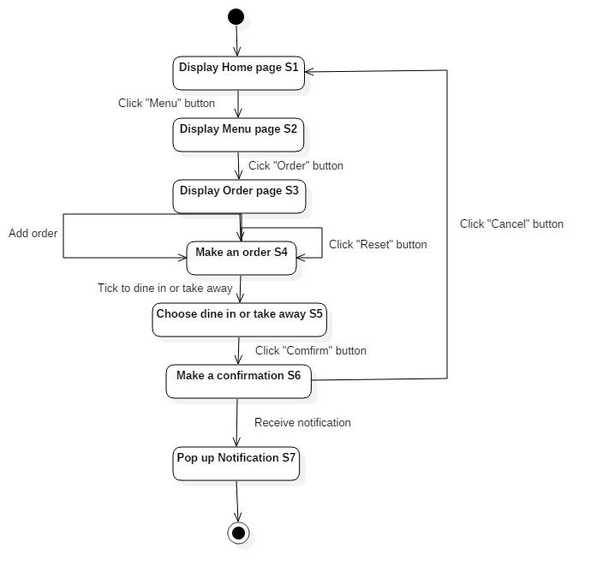

**Figure 2.2.3 Session Verification State Transition Diagram**

The test condition for state transition testing is as follows:

1. TCON-02-014 Session Verification State Transition

|  |  |  |  |  |  |  |  |
| --- | --- | --- | --- | --- | --- | --- | --- |
| **Input\**  **State** | **Click “Menu”**  **(CM)** | **Click “Order”**  **(CO)** | **Click “Reset”**  **(CR)** | **Add order**  **(AO)** | **Tick dine in or take away**  **(DITA)** | **Click “Confirm”**  **(CC)** | **Click “Cancel”**  **(CCAN)** |
| **Display Home page (S1)** | S2/DMP  TCOV-02-014 | S1/- | S1/- | S1/- | S1/- | S1/- | S1/- |
| **Display Menu page (S2)** | S2/- | S3/DOP TCOV-02-015 | S2/- | S2/- | S2/- | S2/- | S2/- |
| **Display Order page (S3)** | S3/- | S3/- | S4/MAO TCOV-02-016 | S4/MAO TCOV-02-017 | S3/- | S3/- | S3/- |
| **Make an order (S4)** | S4/- | S4/- | S4/- | S4/- | S5/CDT TCOV-02-018 | S4/- | S4/- |
| **Choose dine in or take away (S5)** | S5/- | S5/- | S5/- | S5/- | S5/- | S6/MAC TCOV-  02-019 | S5/- |
| **Make a confirmation (S6)** | S6/- | S6/- | S6/- | S6/- | S6/- | S6/- | S1/PN TCOV-02-020 |

**Table 2.2.3a Session Verification State Table**

|  |  |
| --- | --- |
| **Test Coverage ID** | **Test Coverage** |
| TCOV-03-014 | S1 to S2 with input CM |
| TCOV-03-015 | S2 to S3 with input CO |
| TCOV-03-016 | S3 to S4 with input CR |
| TCOV-03-017 | S3 to S4 with input AO |
| TCOV-03-018 | S4 to S5 with input DITA |
| TCOV-03-019 | S5 to S6 with input CC |
| TCOV-03-020 | S6 to S1 with input CCAN |

**Table 2.2.3b Session Verification State Coverage**

## 

## 2.3 Test Identification

This section should contain information at least as below:

|  |  |  |  |
| --- | --- | --- | --- |
| **Test Case ID** | **Description** | **Test Coverage ID** | **Test Condition ID** |
| TC-02-001 | Main flow (Click ‘Menu’ button) | TCOV-02-001 | TCON-02-001 |
| TC-02-002 | Main flow (Click ‘Set Meals’ button) | TCOV-02-002 | TCON-02-002 |
| TC-02-003 | Main flow (Click ‘Add Ons’ button) | TCOV-02-003 | TCON-02-003 |
| TC-02-004 | Click ‘Ala Carte’ button) | TCOV-02-004 | TCON-02-004 |
| TC-02-005 | Main flow (Click ‘Drink’ button) | TCOV-02-005 | TCON-02-005 |
| TC-02-006 | Main flow (Click ‘Order’ button) | TCOV-02-006, TCOV-02-007 | TCON-02-006  TCON-02-007 |
| TC-02-007 | Tick list of food | TCOV-02-008 | TCON-02-008 |
| TC-02-008 | Alternative Flow 2 (Click ‘Reset’ button) | TCOV-02-009 | TCON-02-009 |
| TC-02-009 | Main flow (Tick ‘Dine In’ or ‘Take Order’) | TCOV-02-010 | TCON-02-010 |
| TC-02-010 | Main flow (Click ‘Confirm’ button) | TCOV-02-011 | TCON-02-011 |

**Table 2.1.3 Session Verification Test Identification**

## 2.4 Feature Pass/Fail Criteria

This section should contain information at least as below:

Each feature must satisfy the following criteria in order to pass:

i. pass all its test cases

ii. no deadlock

iii. fulfill its requirement

## 2.5 Test Deliverable

The following documents will be generated by the system test group and will be delivered after test completion.

Test documentation:

i. test plan

ii. test design specifications

iii. test case specification

iv. test procedure specification

vi. test logs

vii. test incident report

vii. test summary report